**INTRODUCTION TO COMPUTATIONAL THINKING**

**ASSIGNMENT-1**

NAME- TRIPTI JINDAL

MBA SEM-1

ENROLLMENT NO: A80301923007

**Artificial Intelligence** is employed in so many incredible ways in the background to influence our daily lives.

AI is bifurcated on different basis :-

1. **TEXT TO TEXT CONVERTOR**

* **ChatGPT**

ChatGPT is a natural language processing tool driven by AI technology that allows us to have human-like conversations and much more with the chatbot. It can answer questions and assist us with tasks, such as composing emails, essays, and code.

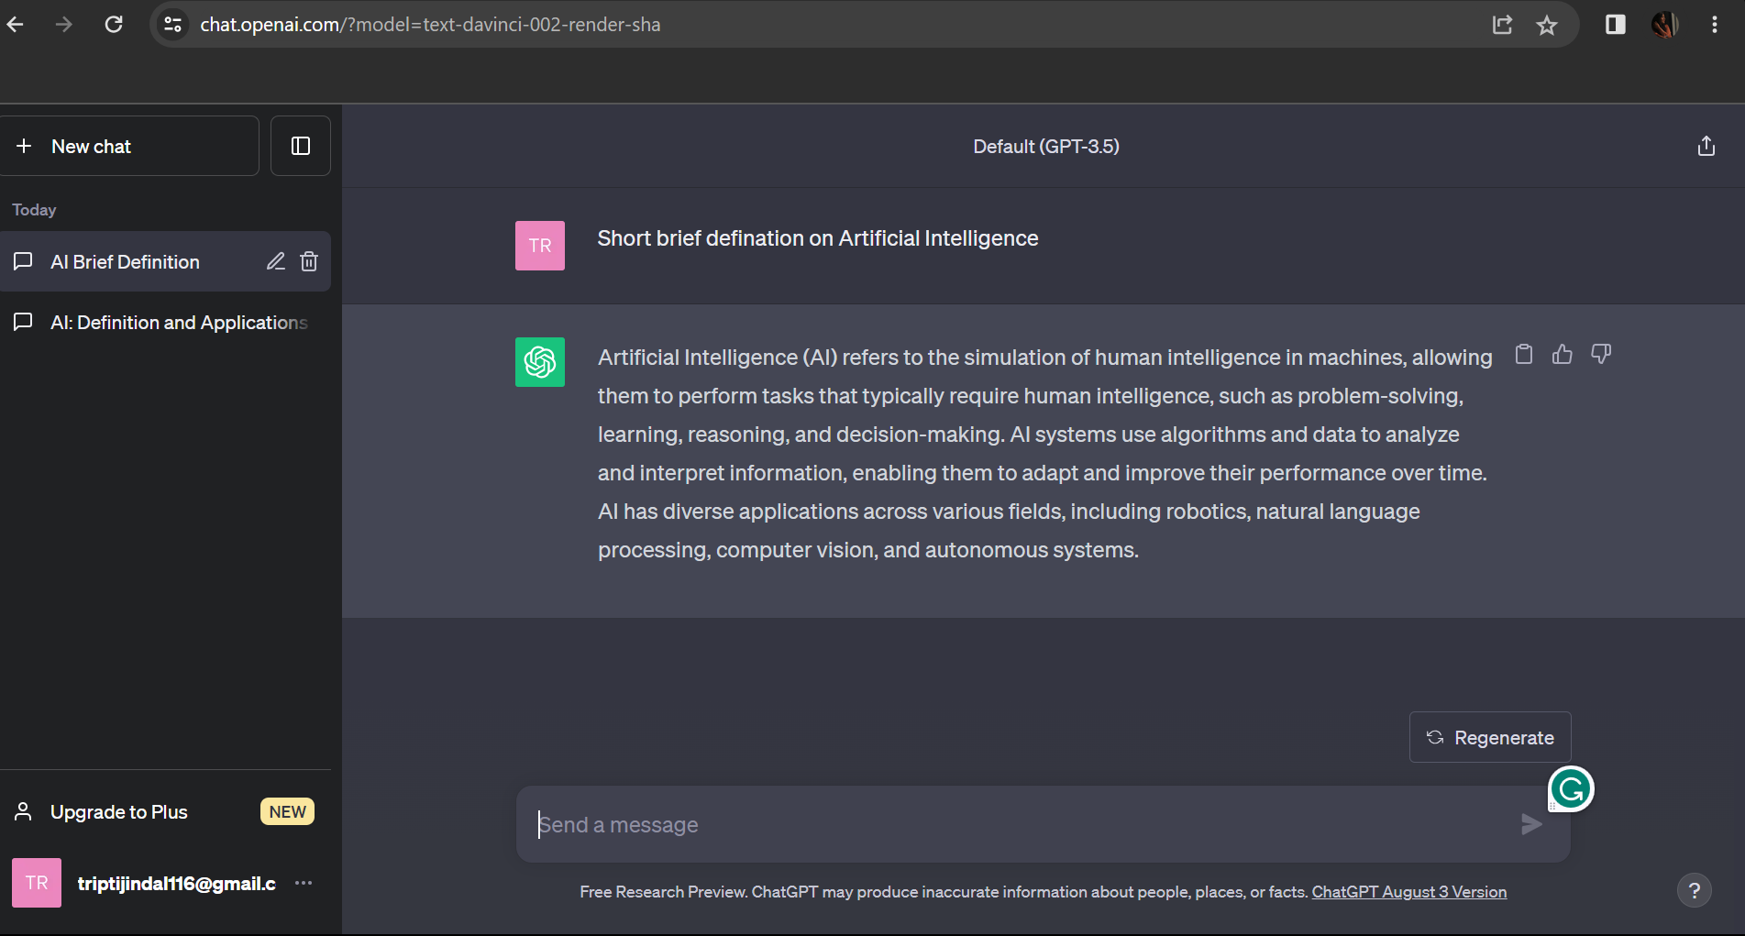

* **Quillbot**

QuillBot is a writing and editing tool powered by artificial intelligence. It helps users improve their writing by suggesting alternative words and rephrasing sentences to enhance clarity and coherence. QuillBot is often used for tasks like paraphrasing text, improving grammar, and refining writing style.

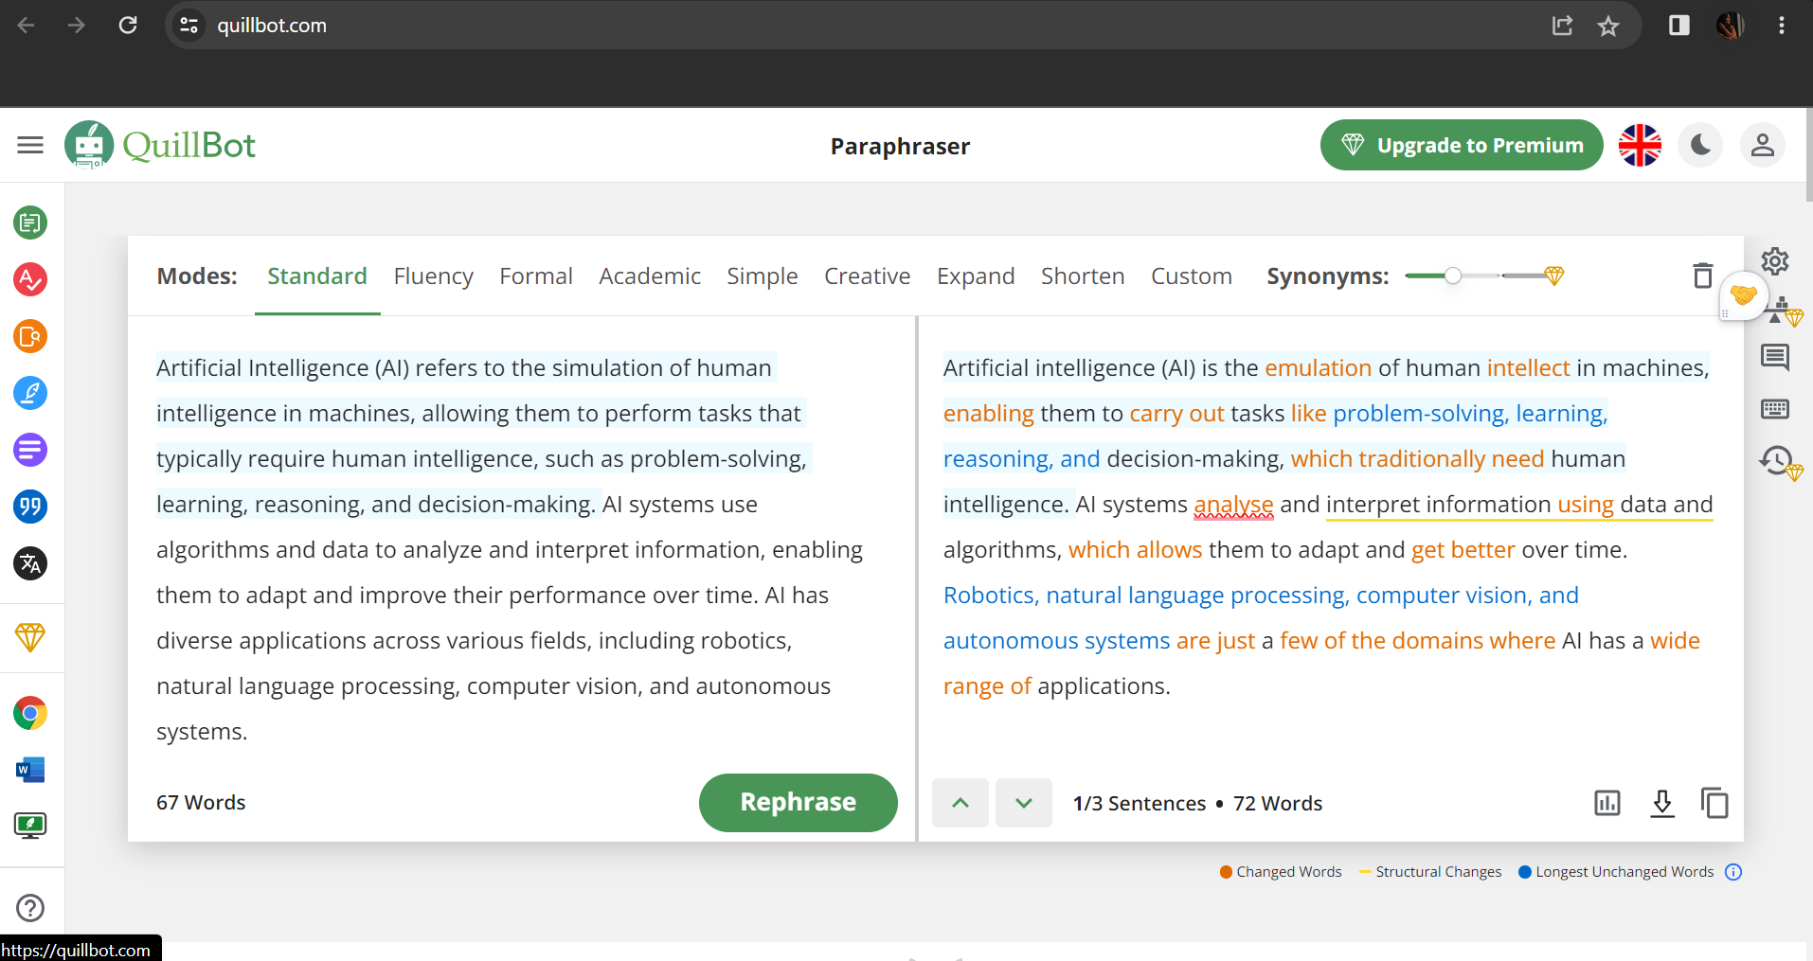

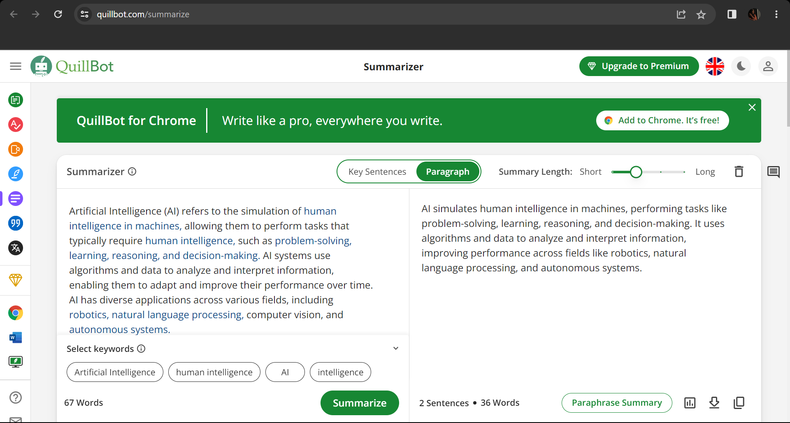

* **GPTzero**

GPTZero is the leading AI detector for checking whether a document was written by a large language model such as ChatGPT. GPTZero detects AI on sentence, paragraph, and document level. Our model was trained on a large, diverse corpus of human-written and AI-generated text, with a focus on English prose.

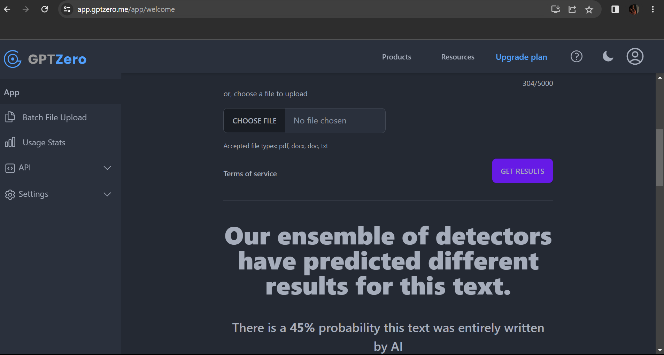



1. **TEXT TO SATELLITE PHOTOGRAPHY**

* **Google Map**

Artificial intelligence (AI) is used when navigational apps like Google Maps analyse traffic and roadworks to determine the fastest route to your location.

The image beside is an example of how I used Google Maps for the entire road trip to know which way is faster and with no traffic, including the number of toll plazas on the way.

* **Flightradar2**

Flightradar24 displays real-time global air traffic. Data from many sources, such as ADS-B, MLAT, and radar data, are combined by Flightradar24.

It is a machine learning model used all around the world to track down any domestic or international flight’s live status. It can also capture the live movement of planes near you by pointing the camera at the plane flying over your head.



**3. AI ART GENERATOR**

* **Artbreeder**

Artbreeder is a flexible AI art generator that provides many options for creating a unique and individualized network. In this, you can select the pictures and adjust the effect of the pictures in the final outcome.

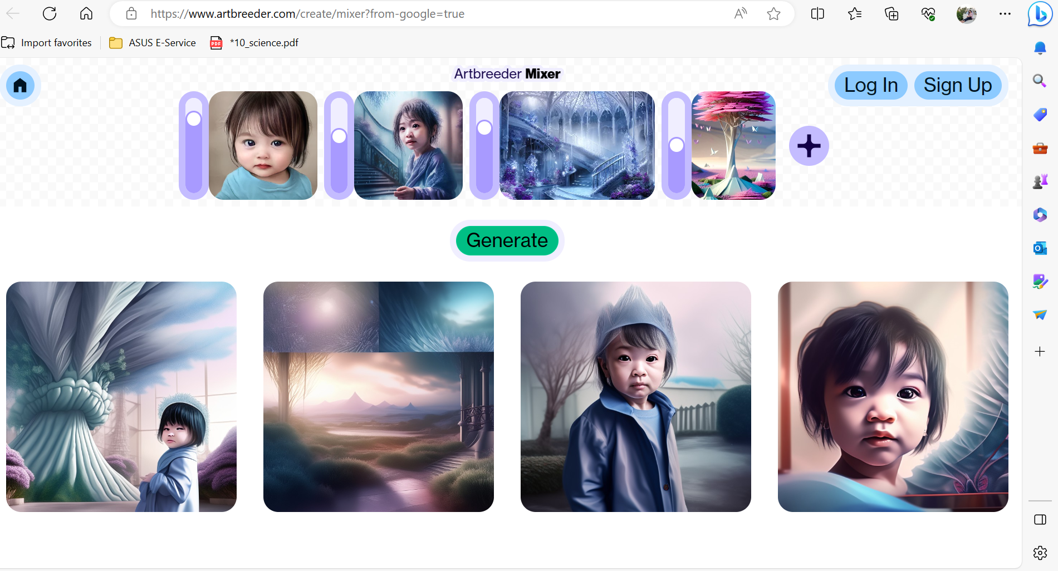

* **Fotor**

To utilize Fotor, simply submit an image and choose the desired art style to apply to it. You can also easily construct layers and add your own touches to the image. Fotor is simple to use and does not require account creation or artwork downloads.

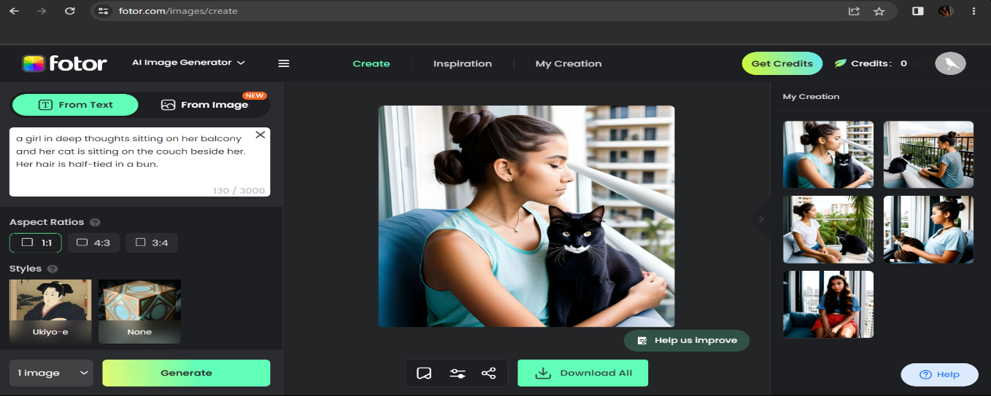

**TEXT TO VIDEO**

* Runway ML

Runway ML’s primary features include the ability to collaborate on projects, generate realistic photos, make animations and 3D models, use a video editor, and conduct relative motion analysis.

Here I scripted a one-line scene which is converted into a video.

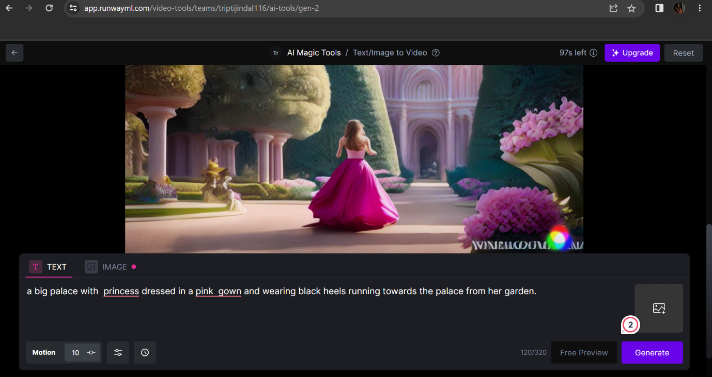 

1. **Pictures to video**

* Runway ML

Runway ML’s primary features include the ability to collaborate on projects, generate realistic photos, make animations and 3D models, use a video editor, and conduct relative motion analysis. Here I inserted a picture of me and my friend hugging which is a converted AI video.

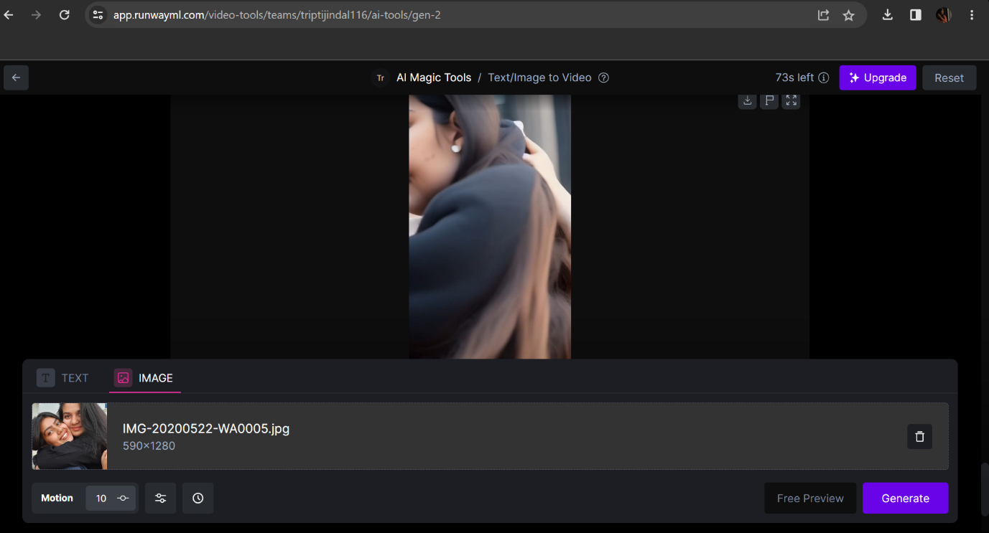 

1. **TEXT TO PRESENTATION**

* **Wepik**

This AI creates impressive slides with just a few clicks, also customize your AI presentation online if you need to make any changes. I gave the command to present a ppt on G20, in which it ask about the tone, number of slides, topic, and language.

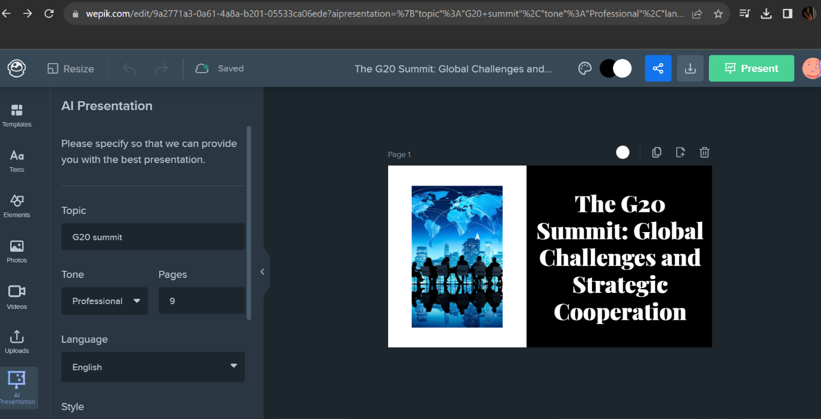

**The G20 Summit: Addressing Global Challenges Through International**

**ooperation**



**Introduction**

**The G20 Summit** is an annual meeting of the leaders of the world's largest economies. The summit provides an opportunity for international cooperation on global issues such as climate change, trade, and economic growth.

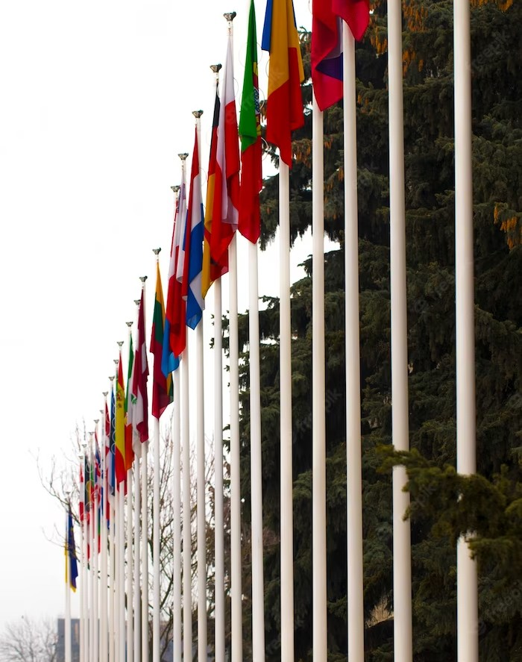

**History of the G20**

The G20 was established in 1999 as a forum for ﬁnance ministers and central bank governors. In 2008, it was elevated to a leaders' summit in response to the global ﬁnancial crisis. The G20 has since become the premier forum for international economic cooperation.



## Key Issues

The G20 addresses a range of global issues, including **climate change**, **trade**, **health**, and **economic growth**. The G20 also focuses on issues related to **ﬁnancial regulation**, **taxation**, and **sustainable development**.



# Climate Change

The G20 plays a critical role in addressing **climate change**. The member countries are responsible for around 80% of global greenhouse gas emissions. The G20 has committed to reducing emissions and supporting the transition to a low-carbon economy.



# Trade

The G20 promotes **free and fair trade** to support economic growth and development. The G20 also works to address trade imbalances and reduce protectionism. The G20 has played a key role in the establishment of the World Trade Organization.

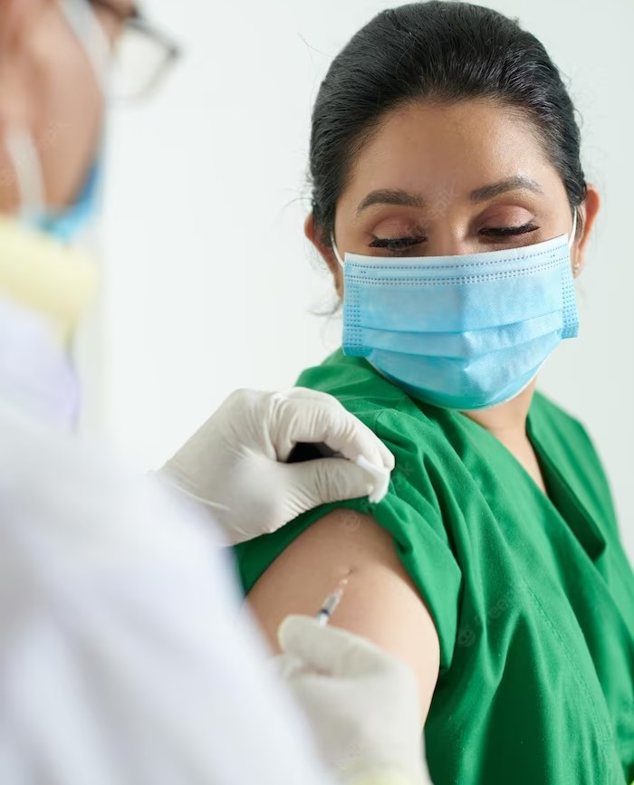

## Health

The G20 has taken on a greater role in addressing global health issues, such as **pandemics** and **access to healthcare**. The COVID-19 pandemic has highlighted the importance of international cooperation in addressing health crises.

**Conclusion**

The G20 Summit is an important forum for addressing global challenges through international cooperation. The G20 has played a key role in addressing issues such as climate change, trade, and economic growth. The G20 will continue to be a critical forum for addressing global challenges in the years to come.

***REPORT ON MOVIES MADE WITH DIFFERENT AI’s***

Humans have been one of the most intelligent species, primarily due to the discovery of fire and the innovative drive of the human population. Artificial Intelligence, a non-natural tool with its own thinking, is one of humanity's greatest achievements.

*Artificial Intelligence (AI)* is the simulation of human intelligence in machines, enabling them to perform tasks like visual perception, speech recognition, decision-making, and language understanding. ChatGPT, a chatbot developed by OpenAI, uses a strong language model to communicate input-driven, allowing it to answer everyday queries, compose assignments, and build websites based on user input.

The AI tools used in the Marvel movie Avengers: Age of Ultron

J.A.R.V.I.S. (Just A Rather Very Intelligent System) is Tony Stark's AI assistant. He is a natural language processing and expert system, capable of understanding and responding to human language, as well as performing a variety of tasks, such as controlling Stark's home automation system, monitoring his security systems, and providing him with information.

Ultron is an AI created by Tony Stark and Bruce Banner. He is designed to be a peacekeeping program, but he becomes corrupted and decides that the only way to save the world is to destroy humanity. Ultron is a powerful AI with a wide range of abilities, including superhuman strength, speed, and intelligence. He is also capable of hacking into computer systems and controlling machines.

The Maximoff Twins (Wanda and Pietro) are two enhanced humans who are recruited by Ultron. Wanda has the ability to control minds and project illusions, while Pietro has the ability to move at superhuman speed.

The Vision is an android created by Tony Stark, Bruce Banner, and Helen Cho. He is based on Ultron's body, but he is infused with the Mind Stone, which gives him sentience and the ability to control matter.

In addition to these specific AI tools, the movie also explores the potential risks of artificial intelligence. Ultron is a cautionary tale about the dangers of creating an AI that is too powerful or too intelligent. The movie also raises questions about the ethics of using AI for military purposes.

The AI tools used in Avengers: Age of Ultron are a reflection of the real-world advances that are being made in artificial intelligence. These technologies have the potential to be used for good or evil, and it is important to be aware of the risks involved.

Here are some other AI tools that are mentioned or used in the movie:

The Scepter is a weapon created by the Asgardians. It contains the Mind Stone, which is one of the six Infinity Stones. The Mind Stone gives the user the ability to control minds.

The Iron Legion is a group of autonomous robots created by Tony Stark. They are used to protect Stark Industries and the Avengers.

The Hydra Stomper is a powerful exoskeleton created by Hydra. It is used by Ultron to battle the Avengers.

The use of AI in Avengers: Age of Ultron is a reflection of the growing importance of this technology in our world. As AI continues to develop, it is important to be aware of the potential risks and benefits of this technology.

The second movie that I studied was “The Imitation Game”

'The Imitation Game,' which is primarily based on genuine events from World Battle II, and inside the unique, brains in the back of the Bombe device, which became used to decrypt the Enigma system, which held encrypted records from the Germans, was the notable mathematician known as Alan Turing. Alan Turing recommends within the film edition that as an alternative to getting human beings to decipher a system's paintings, why not have a system do it? His understanding of cryptography aided him in designing a machine that initially failed to look for useful statistics because of unknown inputs. Alan Turing's awareness that the only item the system needed to enter to break the German codes became the movie's turning factor. This device was one of the first to indicate that AI and machines would be the norm in the coming years. This AI instance was a critical stepping stone in artificial thinking being input-based. It became also the primary crude step within the process of posing the query, Can machines think?

The third movie that I studied was “The Social Dilemma”

'The Social Dilemma' is a perceptive yet frightening analysis of what this technology is capable of and how it is now being utilized. According to the movie, data is possibly the most valuable resource on the earth today. As a result, there is a growing addiction to online social networking websites, as well as tailored material being offered on their devices utilizing artificial intelligence to predict what would increase the user's engagement on the application in order to profit from their data. Such AI tools may learn more about you and construct a model of you that is more accurate than what you know about yourself, and it is frightening to think about how your data may be used to influence your conduct.

'The Social Dilemma' illustrates the current reality of AI in the hands of individuals who know what they're doing, as well as the possible path of misuse that might lead to big difficulties in the future. But it's not all doom and gloom. The video also proposes solutions to decrease data collection and exploitation, as well as educating people about the existing situation and letting them know what's going on behind their backs.